Appendix 13: Ranger training: Vegetation surveys

Ranger Training: Vegetation surveys
Date: 24/6/2003

Introduction:
Plants are primary producers meaning that they are at the bottom of the food chain. Animals and other fauna rely on plants and would not be able to exist without them. It is therefore essential that vegetation changes are monitored in all conservation areas. A negative change in vegetation density or diversity could have serious adverse effects on other ecosystems resulting in a ‘domino effect’ where a reduction in plants affects the numbers of herbivores which in turn affects the numbers of carnivores and so on.
On Aldabra, changes in vegetation have a greater effect on other species than on mainland ecosystems. Suppose a change in water levels around pools in the Cinq Cases area resulted in the die-off of Guettarda speciosa. Tortoises rely on this tree species for shade. Suddenly, the number of G. speciosa trees in halved resulting in only half the shade available for tortoises. Surely this will result in the death of many tortoises!
Or suppose that a steady increase in Stachytarpheta jamaicensis over the years has reduced the biomass of tortoise turf. If this change were not monitored over the years the staff would never realize what was happening. Ten years down the line people are wondering why tortoise numbers have gone down so much!

Following are some reasons why it is important to monitor vegetation on Aldabra:
- To monitor the increase in diversity and abundance of exotic/invasive species such as Stachytarpheta jamaicensis. Exotic or invasive plant species that have been introduced by man may be better suited to life on Aldabra and could ‘push out’ indigenous/local species.
- Changes in the species diversity of plants (the variation in species) could have adverse effects on animals that rely on particular species of plants for their survival. (for example butterflies)
- Changes in biomass (the quantity of vegetative material) are directly linked to abundances of animals which utilize them. A reduction of biomass in the Cinq Cases area will result in a reduction of tortoises.
- Certain areas are more prone to fire hazard than others at certain times of the year. Some areas around the field hut at Cinq cases are highly prone during the dry months. Conducting vegetation surveys in such areas will help identify high risk areas.
- Conducting vegetation surveys involves species identification and a scientific process. All scientific information collected on Aldabra can be used in combination with other studies or used to plan new studies.

Vegetation survey methods:
Different survey methods are used for different vegetation components. On Aldabra we can classify vegetation into 2 broad components namely the woody and herbaceous components. The woody component comprises of upright trees. All species which are ‘woody’ (hard to break) and grow to a considerable size at maturity (over 1m) are grouped in the woody component. The herbaceous component comprises of grasses, sedges, weeds, and shrubs. Herbaceous species are usually small at maturity (less than 1m) and are pliable (easy to bend and break).

The size and length of the survey area will depend on the objectives of the survey. If the objective of a particular survey is to determine the change in the species composition of the woody component from the seaward coast to the lagoon, the transect has to be long enough to encompass all the vegetation types between the sea-shore and the lagoon. On the other hand, if the objective is to determine the percentage of shade afforded in a particular vegetation type, a shorter transect will suffice

1. The belt transect method
This survey method is used in the woody component. The woody component provides shade and leaf-litter which are essential for the herbaceous component. Certain species also live, nest, feed and breed in trees. Furthermore, tortoises and birds rely on trees as a food source. It is therefore essential to monitor the number of individual trees, the diversity of trees and the shade and cover which they provide. All three of these aspects can be monitored and calculated using the belt transect method. This method is essentially the same as we use for tortoise monitoring.

Apparatus
100m tape measure
2m long stick
3m long measuring stick
GPS
Compass

Method
The 100m long tape is placed in a straight line on a random site. It is important to select a random bearing to place the tape on and not to simply select the direction with the least or most trees. The GPS location of the starting point of the transect and the bearing of the transect line are to be recorded. Once the tape has been placed in a straight line both recorders begin moving along the tape holding the 2m long stick perpendicularly to the 100m line. Each tree that is touched by the stick is recorded, this gives an effective transect width of 2m and a length of 100m which calculates to a total survey area of 200m².

The following data is recorded on the data form:
- Tree species
- Distance of tree from the start of the transect (from tree trunk) (A)
- Distance of tree from transect line (from tree trunk) (B)
- Height class (C)
- Height of lowest leaves (D)
- Widest crown diameter (E)
- Narrowest crown diameter (F)

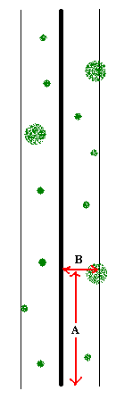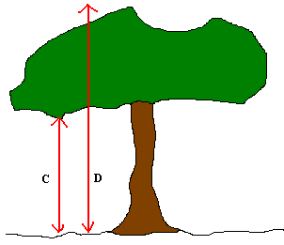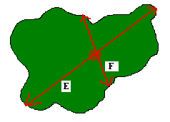

From the data the following can be calculated per transect:
- Number of different species
- Number of same species (dominance)
- Average height class
- Percent shade cover
- Average browse-line height

2. The ‘foot-point’ survey method
The foot-point survey is used to monitor the herbaceous layer. The herbaceous layer is the primary grazing component for tortoises on Aldabra. There is a complex relationship between the abundance, distribution and diversity of herbaceous pant species and tortoises. Previous research has found that tortoises migrate to areas with high densities of palatable (tasty) herbaceous plants and that they rely on these species for survival. It is therefore essential that we monitor changes in both abundance and species diversity of herbaceous plant species. The foot-point survey allows us to monitor both the mentioned aspects

Apparatus
Standard measuring tape
GPS
Compass

Method
As for the belt transect method, this survey requires the effort of two people. One person makes a mark on the tip of his shoe. Once the GPS co-ordinates and the transect bearing is recorded, the person with the marked shoe takes two normal steps down the transect without looking down where he is putting his foot. If the mark on the shoe is directly on top of vegetative material a ‘hit’ is recorded. The species name is then noted on the data sheet. If the mark is not directly above vegetative matter, a ‘miss’ is recorded and the distance between the mark and the nearest vegetative matter is measured and recorded. The species of the nearest plant is also noted. If the mark is more than 1m from any vegetative matter, ‘bare ground is recorded’.

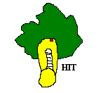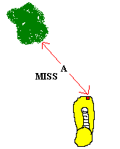

The following data is recorded on the data form:
- The point number
- Whether the mark ‘missed’ or ‘hit’
- If miss, the distance to the nearest herbaceous plant
- If distance to nearest plant is greater than 1m, then record bare ground

From the data, the following can be calculated:
- The species diversity of the herbaceous layer
- The abundance of single species
- The abundance and the cover afforded by herbaceous vegetation.

